Project 2 — Auth0 Implementation:
1.Auth0 Applications Dashboard:

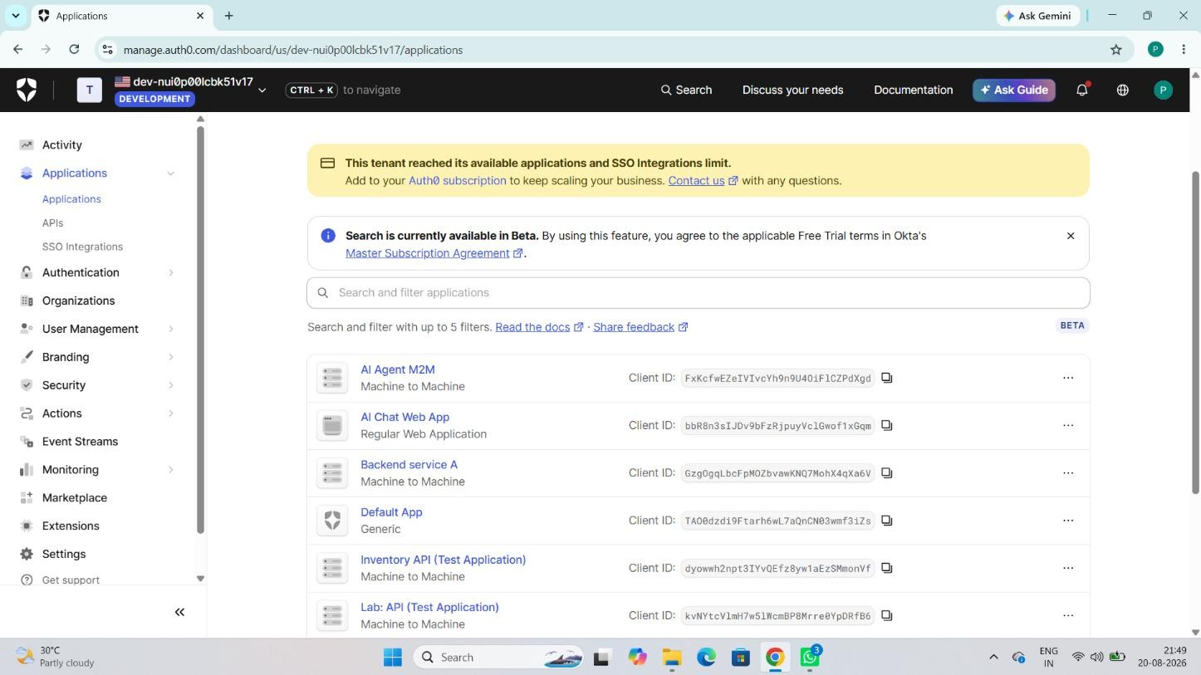
2.Auth0 API Permission:

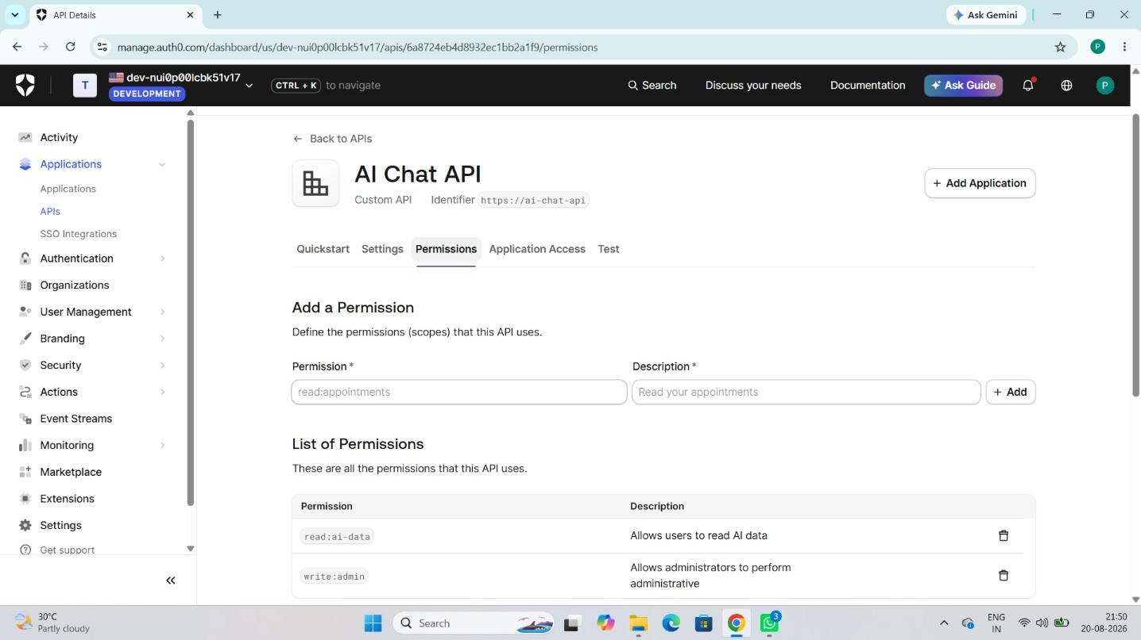
3.JWT_Decoded Token Claims:

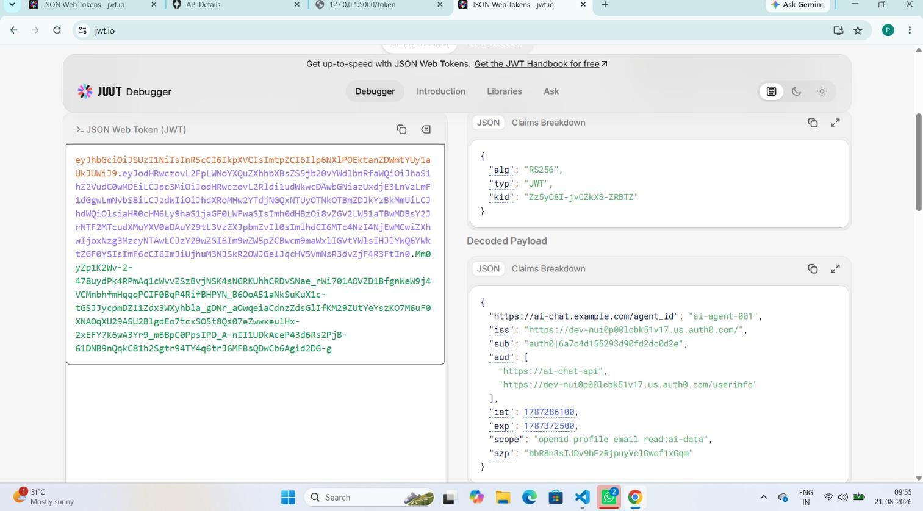
4.Auth0 Universal Login:

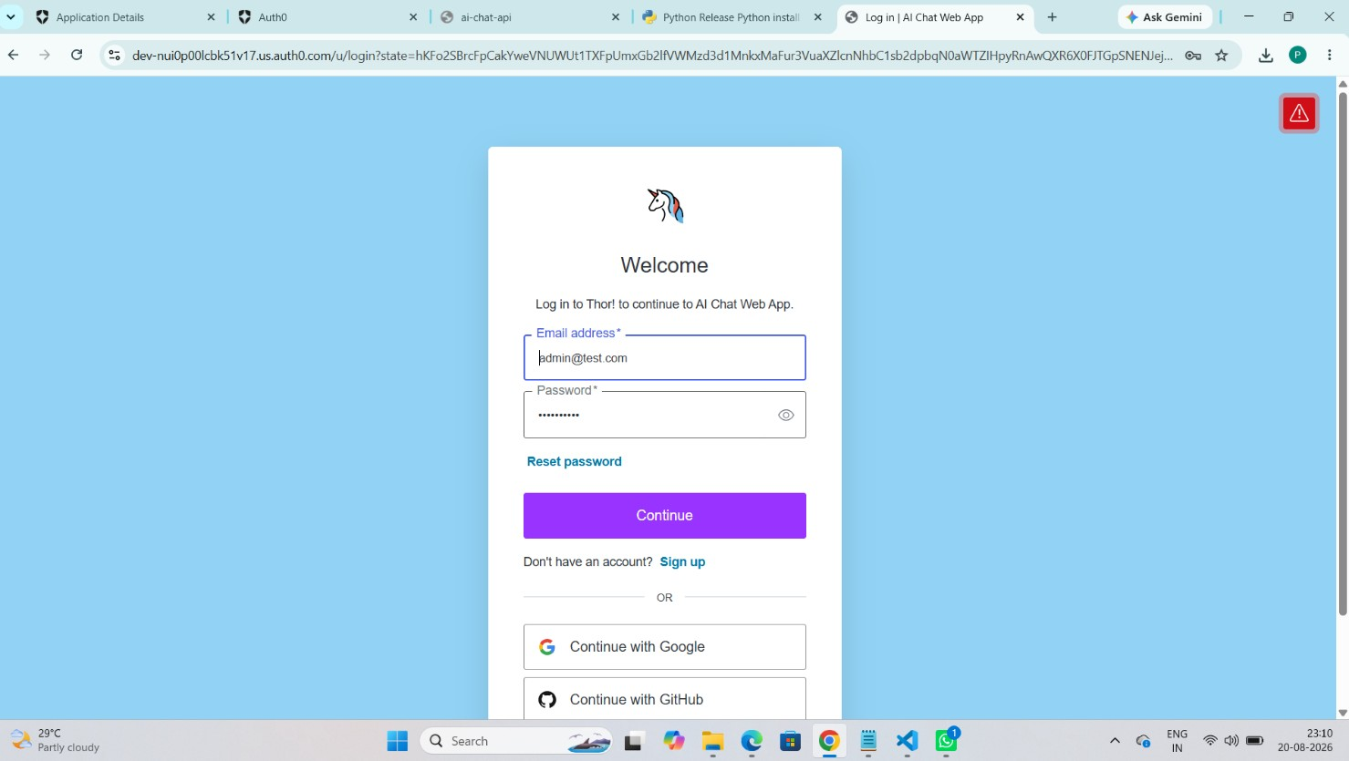

5.MFA / TOTP Verification:

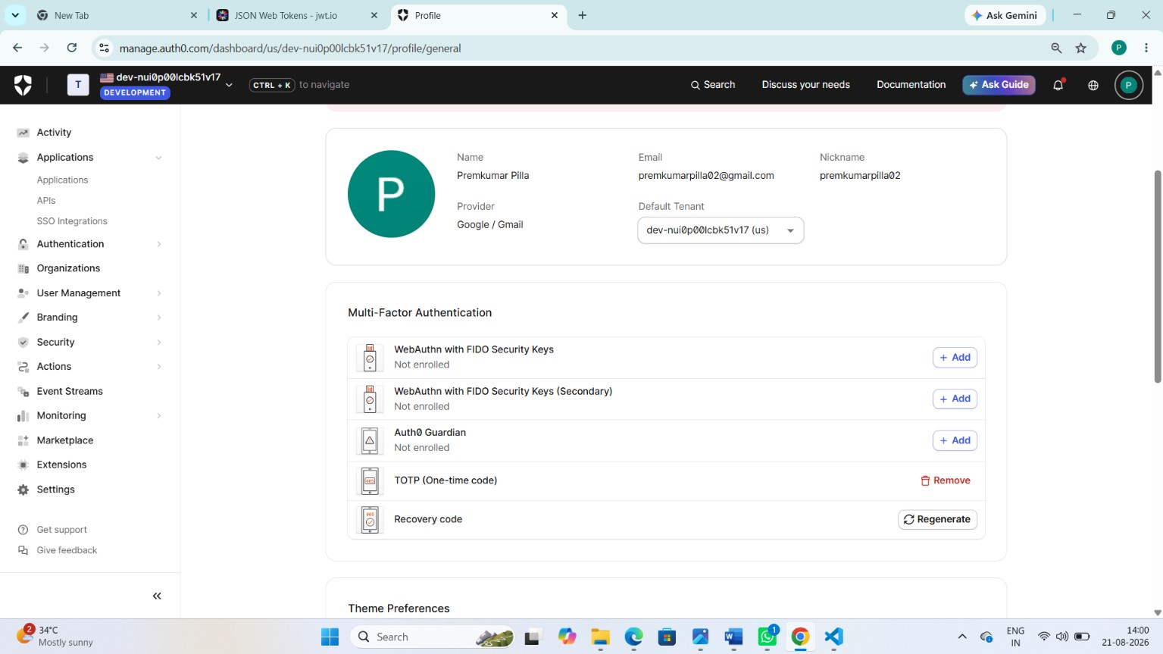
6.Auth0 Actions-Post Login:

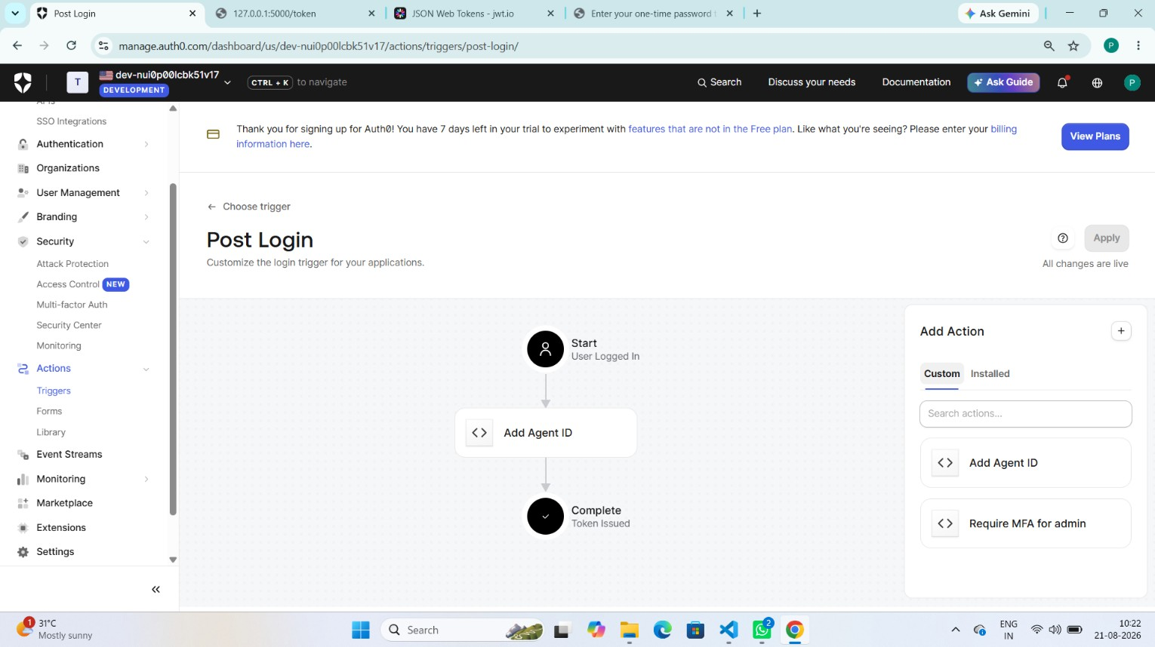
7.Brute-Force Protection:

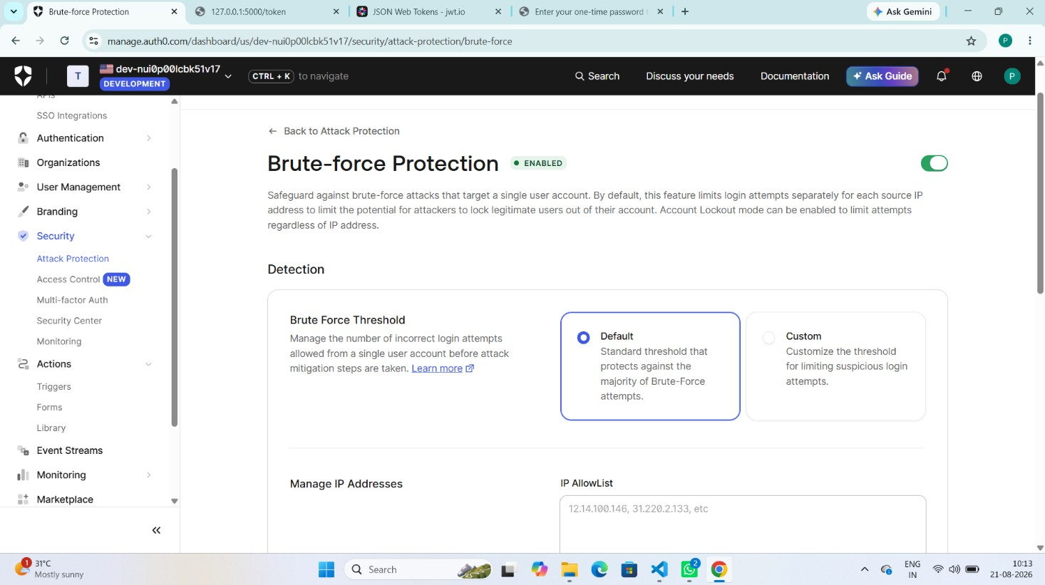
8.Suspicious IP Throttling:

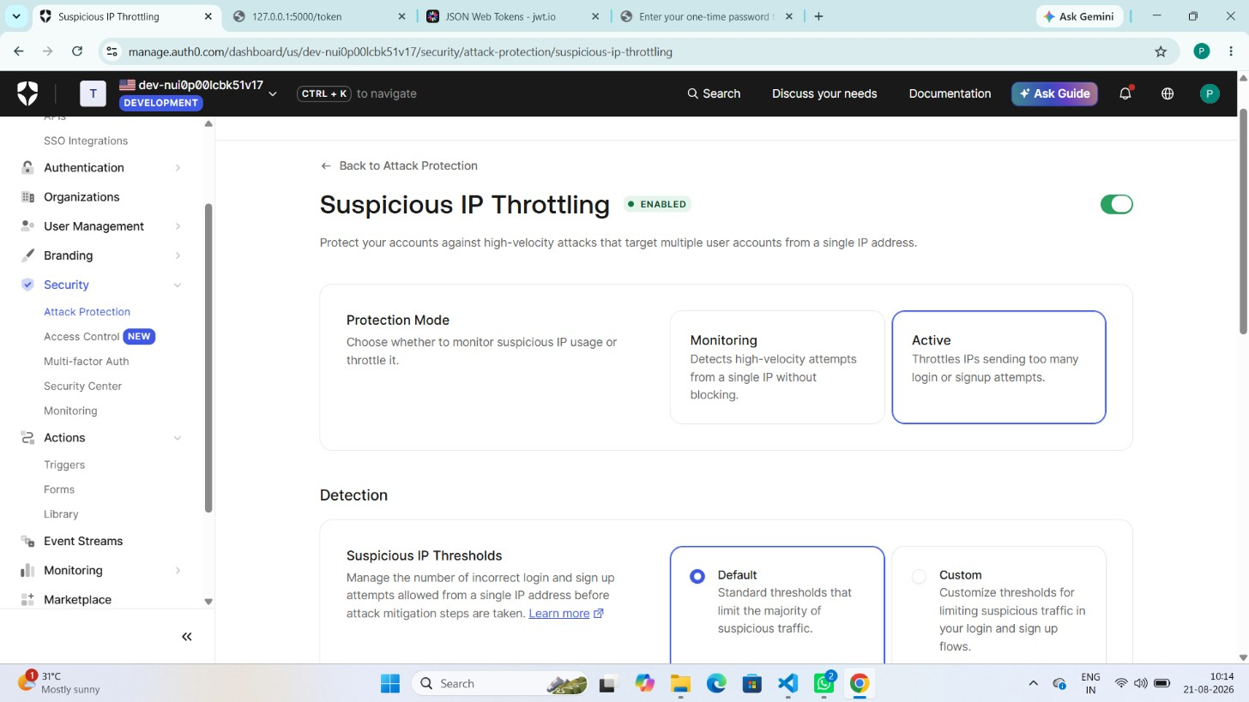

9. Terminal — Credential Rotation Test:

